Customise a card

# Introduction

Figure 1 is an example of a single default card. An individual card can be customised in different ways as explained below. But first, some explanation of the two types of cards, and the different components that can appear on a card.

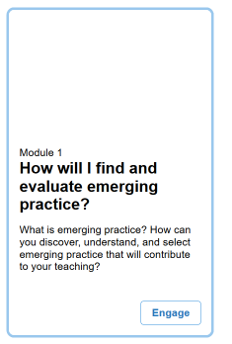

Figure 1 - The default card appearance

# Types of cards: information and navigation

The Card Interface understands two types of card: information, and navigation. The following table summarises the major differences between the two types of cards. The type of card is determined by the type of its matching Blackboard item.

|  |  |  |
| --- | --- | --- |
| **Card** | **Purpose** | **Blackboard Item** |
| Information | Display small bit of information | Content item |
| Navigation | Provide a link to and display a small bit of information about another resource  Can have numeric card labels | Content Folder, Web link, Discussion board, Assessment item or any other Blackboard item that produces a link to another resource |

Figure 2 shows three cards. The first card is an *Information* card. The other two cards are *Navigation* cards.

The *Information* card does not have an engage button as there is nothing to engage with by clicking. It just provides a bit of descriptive text, which in this case talks about the purpose of this page.

The two *Navigation* cards have an engage button if the mouse is placed over these cards, then (as shown by the second card Figure 2) in the entire card will be surrounded by a blue border. Clicking on a *Navigation* card will take the visitor to the link pointed to by the card.

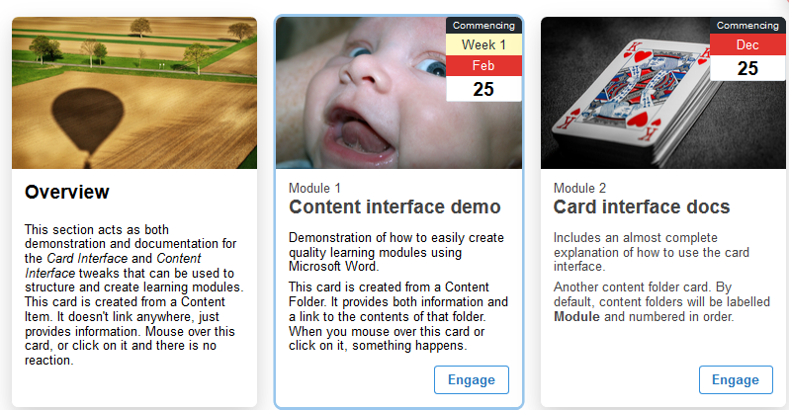

Figure 2 - Collection of two different card types

# The components of a card

Each card can be made up of many different components. Each component serves a different purpose and can be used to customise the card. Figure 3 shows a single card with labels identifying each of the major components. The following table provides more detail on each component.

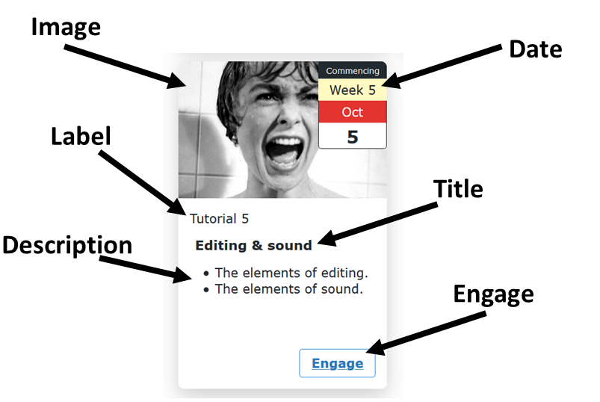

Figure 3 - Components of a Card

|  |  |
| --- | --- |
| Component | Description |
| Image | A visual intended to help students connect/associate conceptually and emotionally with the item the card represents.  Rather than an image this can be a single background colour. |
| Date | Provides an indication to students as to when they should work on the item.  Dates can be explicit (Oct 5) or they can be generic and based on the Griffith University calendar (e.g. Week 5)  The date also has a **Date Label** that can be changed. In Figure 3 the date label is *Commencing*. |
| Label | Identifies the type of object the card represents. For Figure 3 the card represents the fifth tutorial.  The Card Interface automatically calculates the number.  The default label is *Module* but change be changed. |
| Title | Matches the *Name* of the Blackboard item. |
| Description | The *Text* of the Blackboard item. |
| Engage | Provides an additional visual affordance to the viewer that the card is something to be clicked on.  The text for this button or whether there is a button can be customised for all cards on the current page. |

# Adding an image

There are two ways to add (or change) an image, by:

1. Image URL (link).
2. Image upload.

## Image URL (link)

**Pre-requisite:** To use this approach you must know the URL (link) for the image. For example, the URL - <https://djon.es/images/GrandCanyon.jpg> is for a photo of the Grand Canyon.

You can use [Google Images](http://images.google.com/) to [search for relevant images](https://support.google.com/websearch/answer/118238?co=GENIE.Platform%3DDesktop&hl=en), or use other images you find online by [copying the image URL](https://merchantfaq.wish.com/hc/en-us/articles/205211327-How-To-Copy-Image-URL).

**Think twice about using an image URL from the Blackboard content collection**

This can cause problems when you copy the course for a new offering.

### How to do it

1. Edit the content item for the card you with to customise by adding an image.
2. Paste the URL for your image after (and on the same line) as **Card Image:** (e.g. Figure 4)
3. Save your changes.

When you view the page, the card should now be displaying the image from the URL you provided (e.g. Figure 5).

|  |  |
| --- | --- |
| Figure 4 - Content item specifying a card image | Figure 5 - Card produced by transforming Figure 4 |

**Troubleshooting: My card image doesn’t appear**

To double check that you have the correct URL for the image open a new browser window and paste the image URL into browser location. Your browser should open and display the image.

If it doesn’t then your image URL is incorrect.

## Image upload

If you have a digital copy of the image, but don’t have or would prefer not to use a URL then you can upload the image into the Blackboard item.

### How to do it

1. Make sure you have a copy of the image on your computer.
2. Edit the content item for your card.
3. Use [these instructions](https://help.blackboard.com/Learn/Student/Add_and_Format_Content/Add_Files_Images_Video_and_Audio#add-images-in-the-editor_OTP-4) to embed an image in the content item and ensure that the *Image Description* is **Card Image**.  
   It is suggested you embed the image at the bottom of the content item to make it easy to edit the other content.

Figure 6 shows the same content item as Figure 4, but in this case the image is being uploaded into Blackboard. This content item will produce a card that looks the same as Figure 5.

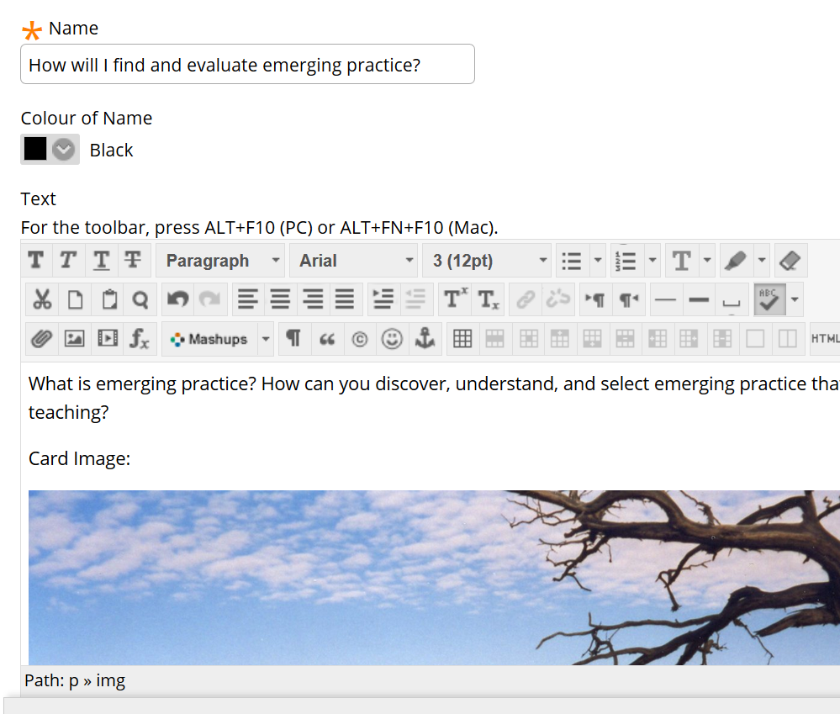

Figure 6 - Content item with image uploaded

# Adding an “active” image

As shown in Figure 3, one of the possible card components is a date or date range. Suggesting that the information contained by the card is particularly relevant for that date or date range.

To reinforce the association between the card and a date it is possible to specify an *active* image for a card. Normally, the card will display the card image specified in previous sections. If there is an *active* image specified, the *active* image will be shown instead when the card is “active”. i.e. when viewed during its specified date or date range.

**Note:** the date and time a card is being viewed is calculated by the web browser and computer used to view the web page. Hence the current time and date is based on that of the viewer.

Given time zones, someone viewing a card from Brisbane may see a different active image than someone viewing the same card from London.

## For example

The following figure (Figure 7) shows a card that has been configured with an active image. Done using the *Card Image Active:* line. The date for this card has been set to *January 12*. The card will be “active” when viewed on January 12.

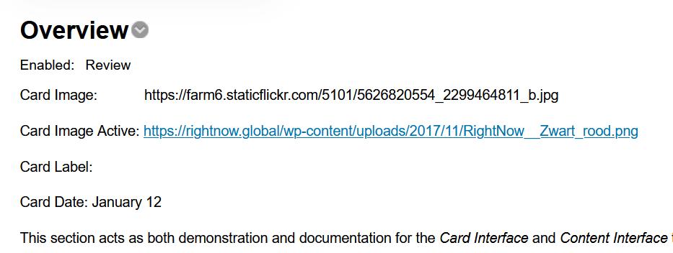Figure 7 - A Card content item with a "Card Image Active" defined

The next two figures are views of this card taken on different days. Figure 8 is what the card looked like on January 11. On January 11, the *Card Image* was shown. Figure 9 is what the card looked like on January 12. On January 12, the *Card Image Active* was shown.

|  |  |
| --- | --- |
| Figure 8 - Viewed on Jan 11 | Figure 9 - Viewed on Jan 12 |

## Possible dates and date ranges

The Card Interface supports three different types of dates or date ranges. The following table summarises these possibilities and how they work with the active image.

|  |  |  |
| --- | --- | --- |
| **Type of date** | **Example** | **When is the active image displayed?** |
| Specific date | January 12 | Between 12am and 11:59pm on January 12 |
| Griffith University Trimester Week | Week 5 | Between 12am Monday and 11:59pm Sunday of the week matching week 5 of Griffith trimester for the course site. |
| Date range | Jan 12-Jan 14 | Between 12am January 12 and 11:59pm January 14 |
| Date range (Griffith) | Week 2-Week 4 | Between 12am Monday Week 2 and 11:59pm Sunday of Week 4 |

# Changing how the image fits the card

  
Figure 10 - Card with a cut-off image

Not all (or perhaps even many) images will fit neatly into the image space on a card. Some images will be too big. Some too small. Some will have [the wrong aspect ratio](https://www.shutterstock.com/blog/common-aspect-ratios-photo-image-sizes). For example,   
Figure 10 shows an image that has been cut off because it is too wide.

There are three options you can use to change how the image fits the card

1. Cover (the default);
2. contain; and,
3. manually resize the image.

**Suggested** [**aspect ratio**](https://support.squarespace.com/hc/en-us/articles/115008538927-Understanding-aspect-ratios) **– 3x1**

Experimentation from someone using the Card Interface found that an image resolution of 2200x720 seemed to work best. At least for 3 cards to a row. Suggesting an aspect ratio of 3x1 as a possible guide.

## Cover – the default

By default (you don’t need to do anything for this to happen) the card makes the image ["cover"](https://tailwindcss.com/docs/background-size/#cover) the available space.  That is, it scales the width and height of the image to ensure there is no unfilled space.

If the image aspect ratio is wrong, you end up with the problem shown in   
Figure 10. Some part of the image extends beyond the available space and is invisible (it is cropped).

## Contain

As an alternative, you can tell the Card Interface to ["contain"](https://tailwindcss.com/docs/background-size/#contain) the image. That is, scale the image height and width so that it fits entirely within the space without cropping or stretching. For example, Figure 11.

With some images, containing an image will result in an image that is too narrow to take up the full width of a card. When this happens, the image will be centered as shown in Figure 12

|  |  |
| --- | --- |
| Top of a card showing the image fully contained (no cropping) within the card  Figure 11 - Card using "contain" to resize a large image | Figure 12 - Card with a centered, contained image |

### How to do it – contain

To specify that an image should be contained, add the following to the relevant content item.

Card Image Size: contain

Figure 13 shows an item with this added and how it changes the image. Compare Figure 13 with the same card shown in Figure 5.

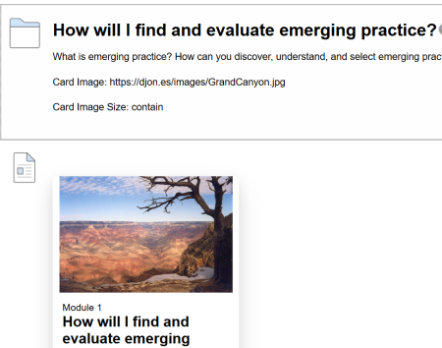

Figure 13 - Adding "Card Image Size: contain" and its impact

## Manually resize the image

If neither cover nor contain provide a suitable method, you can always manually resize or crop the image to produce an appropriate aspect ratio and size.

To do this you will need to use an external tool such as PhotoShop, Paint3D, or one of the [free online services](https://www.google.com/search?q=resize+crop+image+how+to).

# Problem with image appearing in the description

Is the card image appearing in the description, rather than the image section? For example, like Figure 14. The following may help fix this problem.

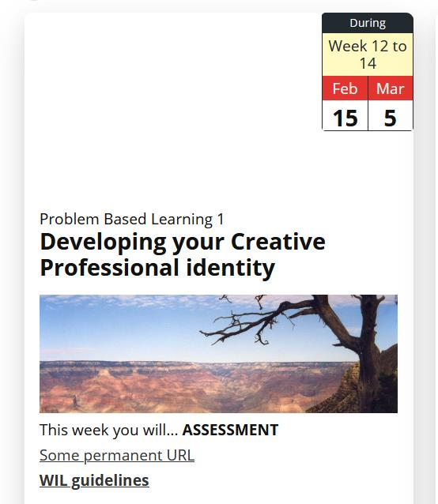

Figure 14 - Problem with card image appearing in the description

## Is the image on the same line as *Card Image*?

For the image to appear in the image section, the image should appear to be on the same line as the *Card Image:* variable. The table and two images below show the difference.

Figure 15 is incorrect. The image (of the Grand Canyon) is on the line underneath the text *Card Image:*. This will result in the image appearing in the description of the card as shown in Figure 14.

Figure 16 is correct. The image and *Card Image:* appear on the same line. This will result in the image appearing in the image section of the card.

### How to fix this problem

In a situation like Figure 15 place the cursor before the image and hit the *Backspace* key. Or, place the cursor at the end of the line with *Card Image:* and hit the *Delete* key. This should produce the outcome shown in Figure 16.

|  |  |
| --- | --- |
| Figure 15 - Image on a different line to "Card Image:" | Figure 16 - Image on the same line as "Card Image:" |

### Origins of this problem

Before early July 2021 this wasn’t a problem. You could have an image on a separate line and it would still appear in the right spot.

This was because of a bug in the code for the Card Interface. This bug meant that you could not include an image in the description. For example, like the icon in Figure 17.

The bug was fixed in early July 2021.

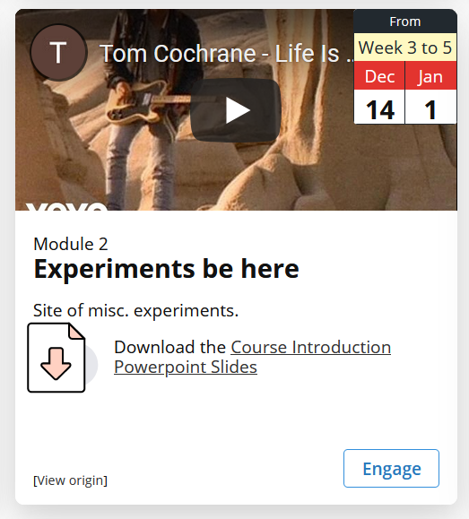

Figure 17 - Example card with an icon in the description

# Using a background colour

As shown in Figure 1 if no card image is provided the image space will show a background colour of white. As shown in Figure 18 there are at least four options for background colour and background image. These options are achieved through different combinations of card meta data summarised in the following table.

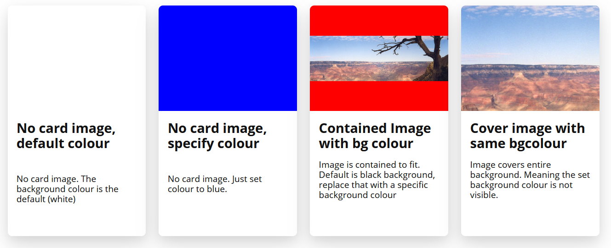Figure 18 - Four options for background image and background colour

|  |  |  |
| --- | --- | --- |
| **Option** | **Card Meta Data** | **Result** |
| No card image, default colour | Card Image: | No image shown, instead the default white background is shown. |
| No card image, specify a different colour using Card Image | Card Image: blue | No image shown, instead the specified colour is used for the background |
| Contained image with background colour | Card Image: https://bblearn-blaed.griffith.edu.au/bbcswebdav/pid-6273897-dt-content-rid-47239287_1/xid-47239287_1  Card Image Size: contain  Card Image Background: rgb(255,0,0) | The image is shown, but it’s size does not take up the entire space available (either due to the dimensions of the image or use of the “contain” option). Where the background shows it shows the specified background colour |
| Cover image with background colour | Card Image: https://bblearn-blaed.griffith.edu.au/bbcswebdav/pid-6273897-dt-content-rid-47239287_1/xid-47239287_1  Card Image Background: rgb(255,0,0) | The card image covers the entire background. Even though a background colour is set, it does not appear. It’s covered by the image. |

### How to specify a background colour

Background colours are specified using one of [the CSS Legal Colour Values](https://www.w3schools.com/cssref/css_colors_legal.asp) as parameters to either the **Card Image** or **Card Image Background** card meta data variables. The table above includes examples of rgb colours – rgb(255,0,0) – and predefined color names – blue. Further examples of these different colour values can be found online, including: [HTML colour name](https://www.w3schools.com/colors/colors_names.asp)s; [colour hex code](https://www.color-hex.com/)s; [rgb function](https://www.w3schools.com/cssref/func_rgb.asp)s; and also one of the many [HTML colour pickers](https://www.google.com/search?client=firefox-b-d&q=html+colour+picker) on the Web that can help you choose a colour.

# Use a video, PowerPoint presentation etc. instead.

You may prefer to use a YouTube video, PowerPoint presentation or other form of shareable web content. For example, Figure 19 shows a card with a YouTube video instead of a card image. The video can be played, expanded etc from within the card.

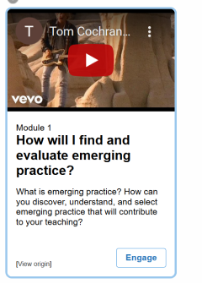

Figure 19 - Card using a YouTube video rather than an image

### How to do it

1. Copy the embed code for the video or other resource you want to use.  
   (e.g. here’s how to [get the embed code for a YouTube video](https://support.google.com/youtube/answer/171780?hl=en))
2. Edit the Blackboard item matching the card.
3. Change **Card Image:** to **Card Image Iframe:**
4. Use the [*View HTML* button](https://sites.reading.ac.uk/tel-support/2019/08/30/blackboard-view-html-code/) on the editor to paste the embed code next to **Card Image Iframe:**  
   For example, Figure 20 has highlighted the embed code for the YouTube video being pasted into the item for Figure 19.

**Warning!** The HTML you paste should start with **<iframe** and end with **</iframe>**. As shown in Figure 20.

There should not be any other tags (especially **<div>**) before or after **<iframe></iframe>**. The presence of such tags will cause problems. Figure 21 demonstrates this situation with Microsoft Stream’s responsive embeds.

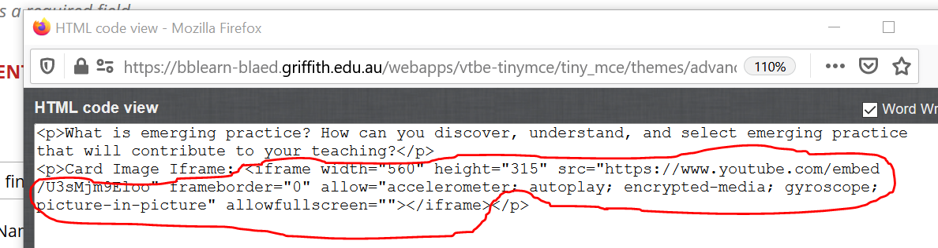

Figure 20 - Pasting the embed code for Card Image Iframe

### Problems with Microsoft Stream’s responsive embeds

[Microsoft Stream](https://www.microsoft.com/en-ww/microsoft-365/microsoft-stream) is an increasingly common video hosting platform. It provides an embed feature which includes the option to create responsive HTML. Figure 21 is an example of this responsive embed option.

To provide this responsive embed option Microsoft Stream will place additional tags around the **<iframe>** this will not work with the *Card Image Iframe* approach.

The solution is not to select the *Responsive* option.

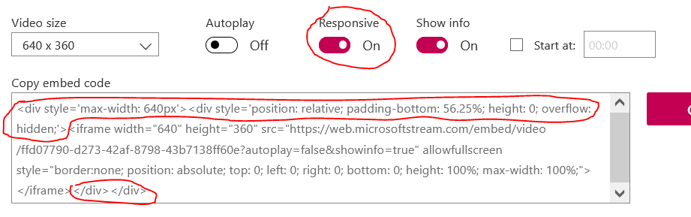

Figure 21- Responsive embed HTMl from Microsoft Stream places tags around <iframe></iframe> - won't work with Cards

# Adding a date (or date range)

There can be value in providing students with suggestions as to when they should engage with the activities and resources associated with a card. Figure 22 provides six examples of different ways you can add a date or a date range to cards. Dates are displayed using a calendar-like element in the top left-hand corner of the card.

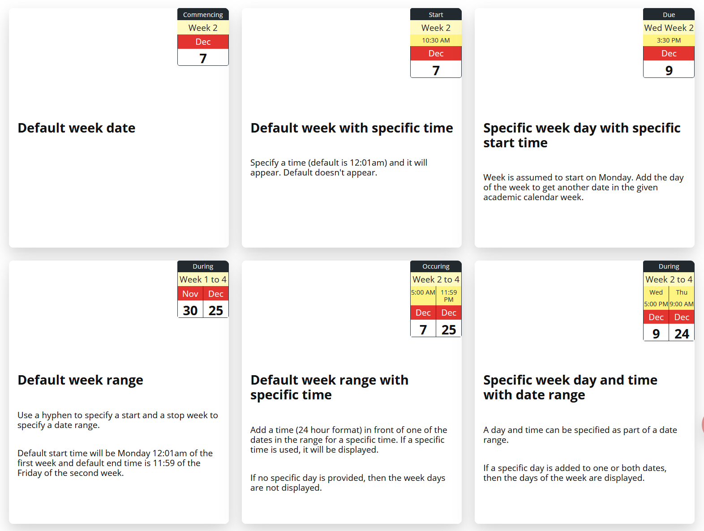

Figure 22 - Six example card dates and date ranges

Dates are added to a Card using two card variables:

1. *Card Date:* to specify the actual date/time.
2. *Card Date Label:* to specify the label to describe the date (e.g. Commencing; Start; Due etc).

Dates can be provided in two formats:

1. University dates – dates linked to the Griffith University calendar and the study period/trimester associated with the current course site. e.g. *Week 3* and *Thu Week 5*
2. Specific dates – combinations of month and date (no year supported). e.g. *Dec 25*

Examples and explanation of each date format is provided in the following sections.

**University dates are automatically updated**

As course content is copied from course site to course site, generic dates (e.g. *Week 2* or *Wed Week 5*) will be automatically updated to use the dates associated with the study period/trimester of the new course site.

## University Dates

The following table shows and explains the combination of variables used to produce the card dates shown in Figure 22.

|  |  |
| --- | --- |
| **Variables** | **Explanation** |
| Card Date: Week 2 | No *Card Date Label* means that the default label (Commencing) is used.  The date *Week 2* is interpreted to mean Monday of the 2nd week for the Griffith University study period or trimester associated with the course site on which the cards appear. |
| Card Date Label: Start  Card Date: 10:30 Week 2 | A specific date label is provided, it is used.  A specific time (using [24-hour time](https://simple.wikipedia.org/wiki/24-hour_clock)) is provided. But the rest of the date stays the same as the first. Only the new time is added to the display |
| Card Date Label: Due  Card Date: 15:30 Wed Week 2 | Another different date label is provided  We’re still using a generic University week (*Week 2*) but both a time (*15:30*) and day of the week (*Wed*) has been provided.  Since Monday Week 2 is December 7 (see the first card), Wednesday Week 2 is December 9. |
| Card Date Label: During  Card Date: Week 1-4 | Another different date label.  This time a date range is provided. Staring with week 1 and finishing with Week 4.  As University practice, a week starts on Monday (12:01am) and finishes on Friday (11:59pm). The dates displayed are Monday Week 1 and Friday Week 4 |
| Card Date Label: Occurring  Card Date: 5:00 Week 2-4 | Another date label is specified.  This date suggests that 5:00am (5:00 is in 24-hour time) on Monday (the default day) Week 2 is the start of a range, with Friday (11.59pm) of week 4 the end. |
| Card Date Label: During  Card Date: 17:00 Wed Week 2-9:00 Thu Week 4 | Using *During* as the date label  Both the start and stop of the date range have specified specific times and days of the week. From 5:00pm Wed of Week 2 through to 9:00am Thursday of Week 4 |

## Specific Dates

Use of specific dates should generally be avoided as they need to be manually updated if a course site is re-used in a different offering.

Figure 23 shows examples of dates created using specific dates. The following table shows and explains the combination of card variables used to create the dates for each of these cards.

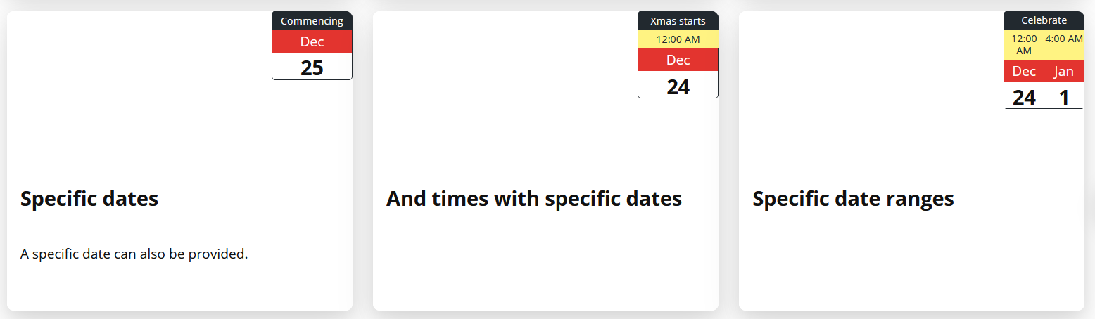

Figure 23 - Example cards with specific dates

|  |  |
| --- | --- |
| **Variables** | **Explanation** |
| Card Date: Dec 25 | December 25 specified using the three letter abbreviation for the month. |
| Card Date Label: Xmas starts  Card Date: 0:00 Dec 24 | Use the *Card Date label* variable to provide a specific label.  Specify midnight on December 24 as the time/date. |
| Card Date Label: Celebrate  Card date: 0:00 Dec 24-4:00 Jan 1 | Another different date label is provided  Specify a date range starting at midnight on December 24 and finishing at 4am on January 1.  No year can be provided or displayed. |

# Changing the card label

As shown in Figure 3, by default all cards have a label intended to indicate what type of information or object the card provides (information card) or pointing to (navigation card). A card label has two components:

1. name; and  
   By default, the label name is *Module*, but it can be changed.
2. number.  
   By default, the label number if automatically incremented so that the second “module” card has the number 2. See **Removing the Card Number** below for how to turn off the number.

**Multiple independently numbered label names now supported**

Before 2021, the automatic incrementing of numbers would only work for a single label name. i.e. you could have *Module* or *Topic*, but not both.

It is now possible – as shown in Figure 24 – to have multiple labels with each label’s number being automatically incremented separately.

## Card label example

For example, the card interface in Figure 24 illustrates how labels can be used.

The first card – *What’s next?* – does not have a card label. Three of the cards have the label *Module* and are numbered sequentially from one to three. Two other cards have the label *Personal Change*.

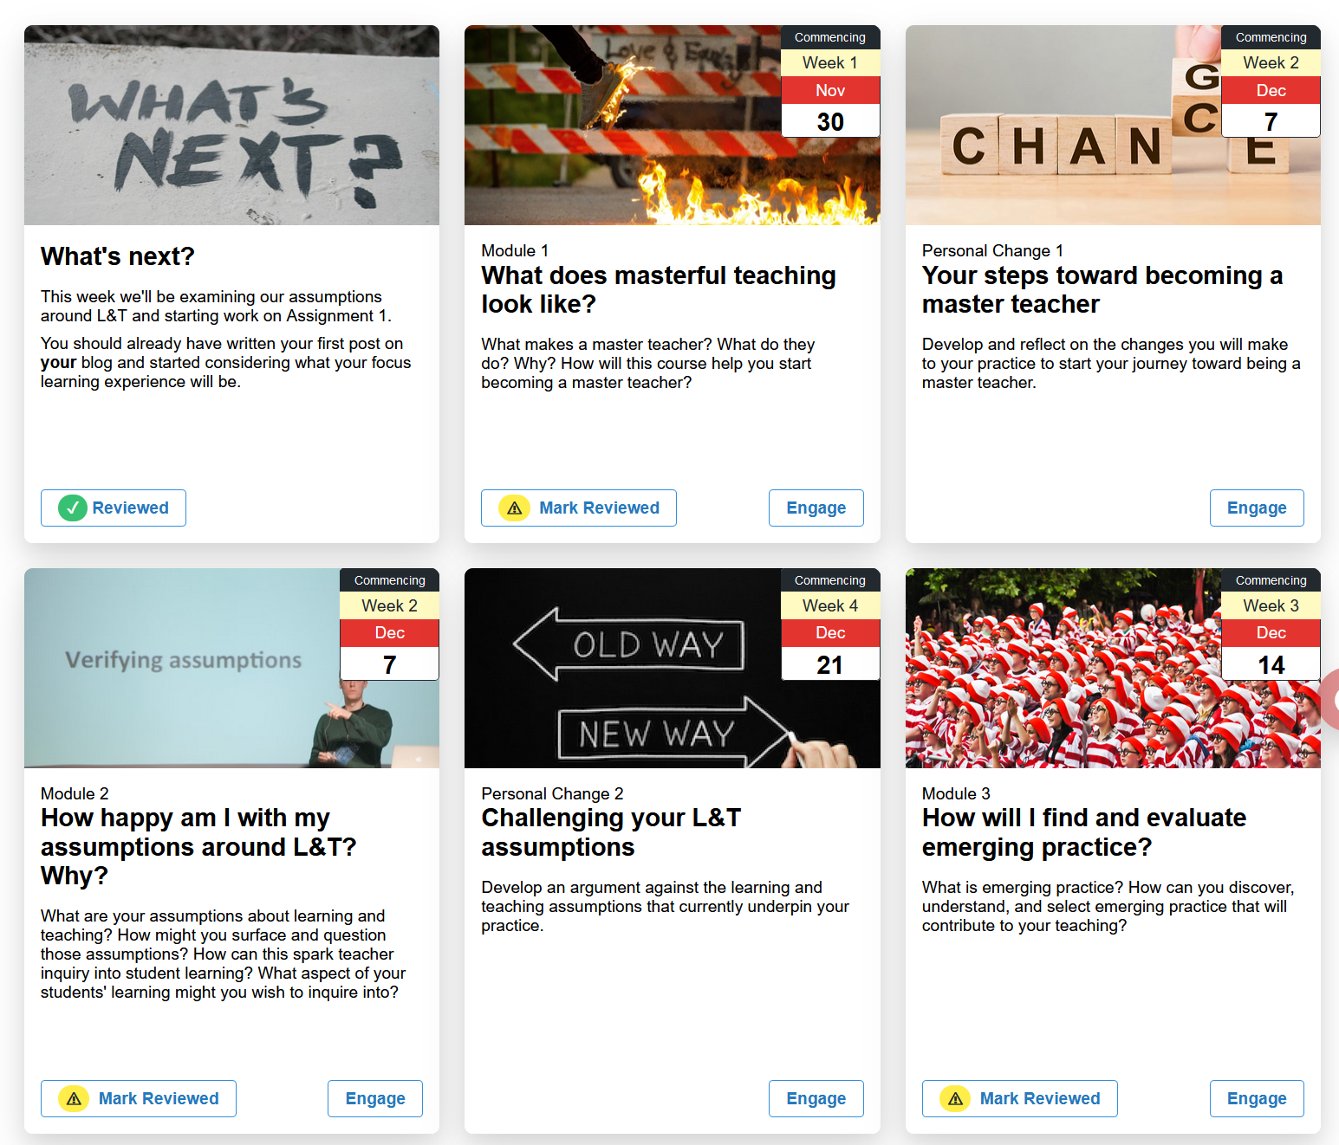

Figure 24 - Card Interface showing different labels

## Changing the card label

To change the card label, add a line to the description for the Blackboard item to include

Card Label: newLabelName

For example, the Blackboard item in Figure 25 is used to produce the *Your steps toward becoming a master teacher* card in Figure 24.

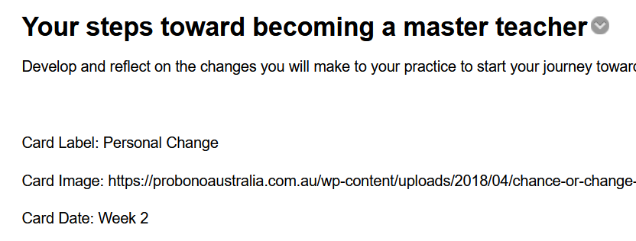

Figure 25 - Blackboard item with different card label

## Removing the Card label

If you don’t wish to give a navigation card a label (e.g. the *What’s next?* card in Figure 24) you ensure that the Blackboard item contains an empty *Card label* line.

Card Label:

For example, the item shown in Figure 26 is used to produce the What’s next? card in Figure 23.

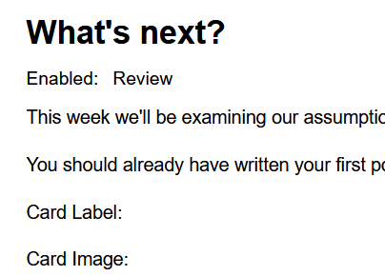

Figure 26 - Navigation card with an empty label

# Changing the Card Number

As shown above, a card label consists of a name and a number.

By default, the card number starts at 1 and increments for each card of a given label i.e. Module 1, Module 2, Module 3. The order of numbering is controlled by the order in which the items appear in the Blackboard page.

## Change the order of items and you will change the numbering

Blackboard allows you to [change the order of items](https://help.blackboard.com/Learn/Instructor/Course_Content/Create_Content/Edit_and_Manage_Content#reorder-content_OTP-4). Changing the order of items will change the order of numbering. However, the numbering will always start at 1.

**Reload the page after changing the order**

Changing the order of items in Blackboard happens in the page. Meaning it does NOT change what you see in the card interface.

To see the changes, you will need to reload or refresh the Blackboard page.

## Use “Card Number” to change the numbering

Figure 27 has been modified to change the numbering of the cards shown in Figure 24. Rather than starting at 1. The *Module* cards start at 55.

This was done by adding the following to the *What does masterful teaching look like?* Card

Card Number: 55

This sets the current card’s number to 55 and ensures that all subsequent cards with the same label are numbered incrementally from there (56, 57, 58…)

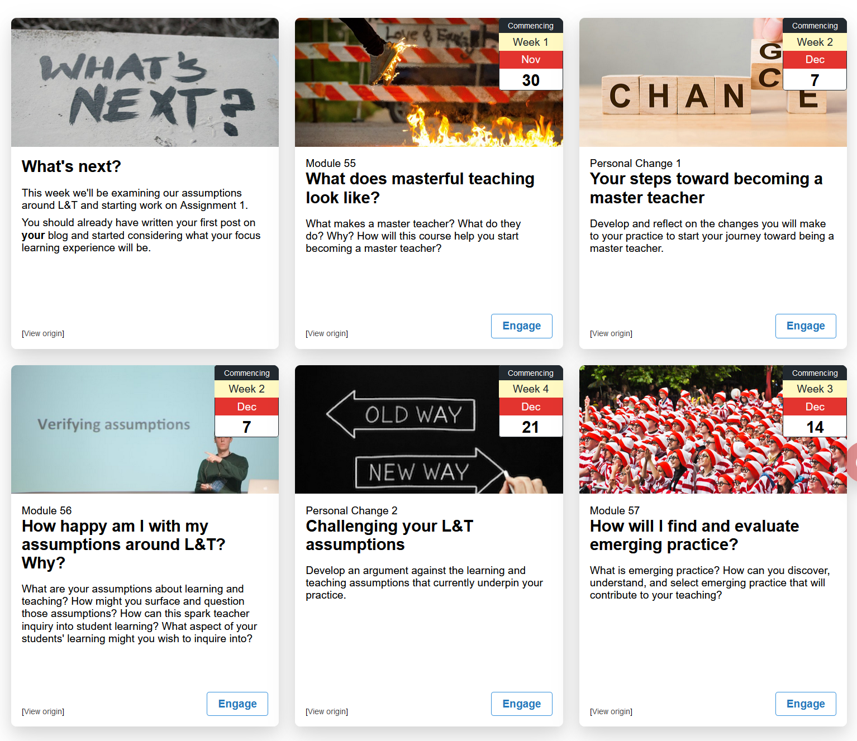

Figure 27 - Example of how card number can be used

# Removing the card number

As mentioned above a *card label* typically has two parts: a name and a number. If you wish for the label to include the name, you must remove the card number. This can be two different ways:

1. for a single card; or,
2. for all cards.

## Remove the card number for a single card

For example, the third card in Figure 27 has the label **Personal Change 1**. To remove the number (**1**) you add to the item description.

Card Number: none

For example, Figure 28 which produces

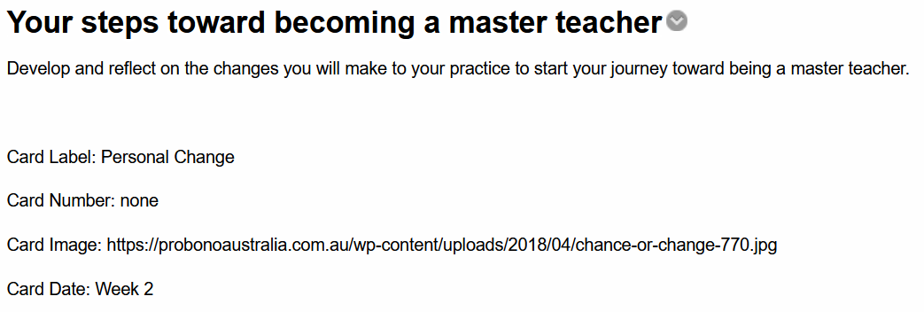

Figure 28 - Removing the card number from a single card

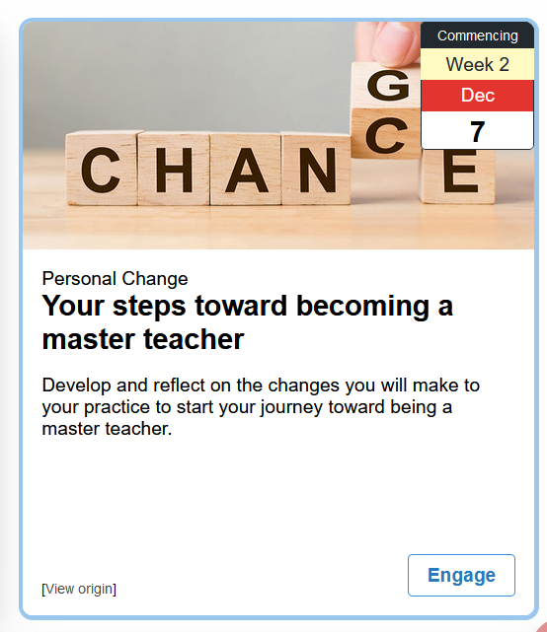

Figure 29 - Example card with a card label, but no card number

## Remove the card number for all cards

If you wish to remove the Card Number from all of the cards with Card Labels, then you add to the title of the card interface element

noCardNumber

For example, the change in Figure 30 removes all the card numbers from Figure 27 to produce Figure 31.

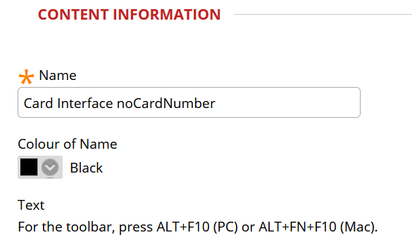

Figure 30 - How to turn off the card number for all cards with labels

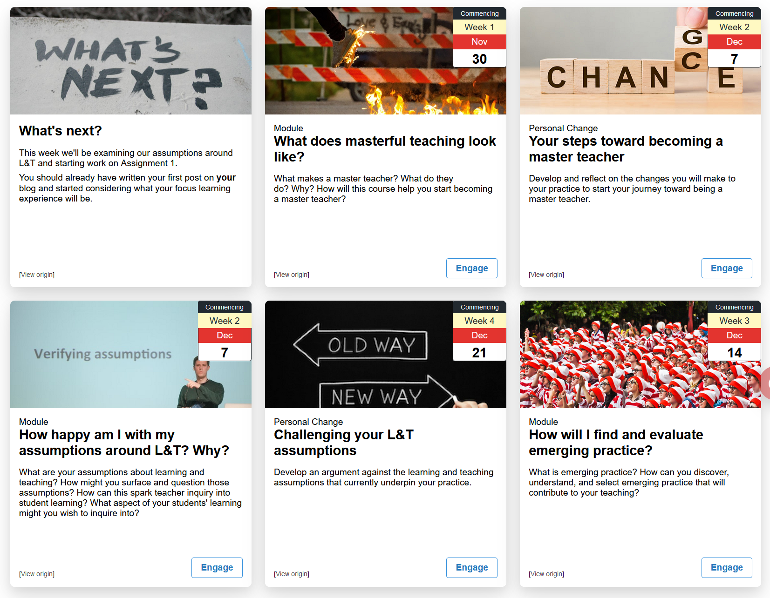

Figure 31 - All card numbers removed

# Changing a card’s Engage button

As shown in Figure 31, by default each Card that links to another resource will have an **Engage** button. It is possible for you to change the label on the engage button either for the [entire collection of cards](https://djplaner.github.io/Card-Interface-Tweak/customiseAllCards/#how-to-change-or-remove-the-engage-button) or for each individual card (explained below)

Changes made to an individual card’s engage button are applied first.

Figure 32 is an example of a Card Interface where each card’s engage button has been changed in someway.

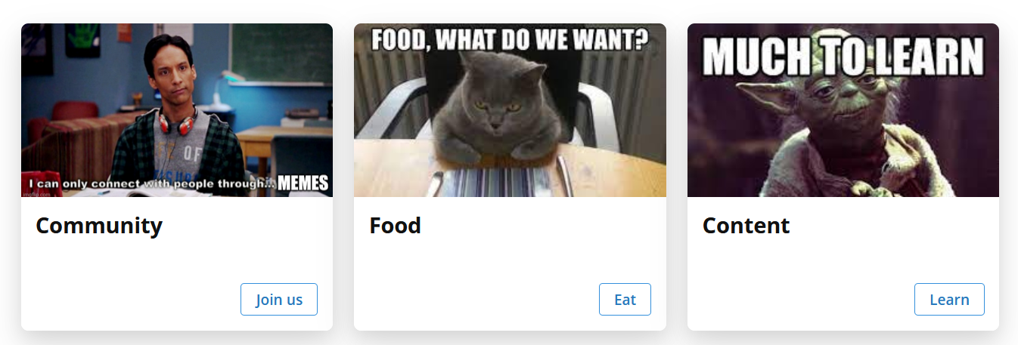

Figure 32 - Different engage button labels for each card

## How to do it

To change the engage button for a card you include the card variable **Card Engage** in the card’s content. The value for the variable is the replacement label for **Engage**. For example, the first card in Figure 32 includes

Card Engage: Join us

Figure 33 shows the Blackboard content items used to create the Card Interface in Figure 32. It shows that the first two items – Community and Food – have used the **Card Engage** variable to change the engage button label for that card.

However, the last item – Content – does not use the **Card Engage** variable and yet the engage button for this card in Figure 32 has the label **Learn**, rather than **Engage**. This is achieved by using [the feature to change the engage button](https://djplaner.github.io/Card-Interface-Tweak/customiseAllCards/#how-to-change-or-remove-the-engage-button) for the entire card interface to **Learn**.

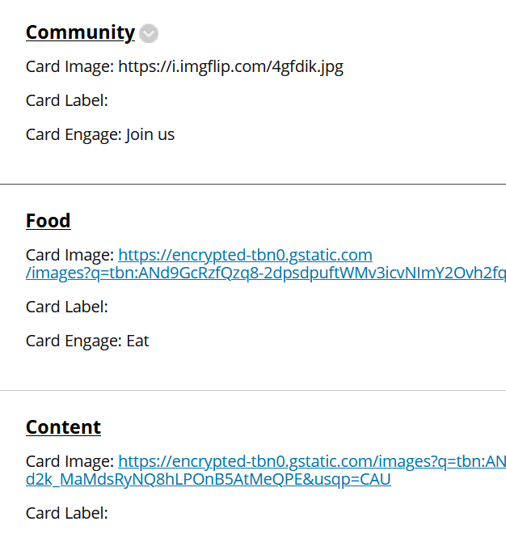

Figure 33 - Content items used to create the Card Interface in Figure 32

# Hiding a card

Sometimes you don’t want a card to appear. e.g. you don’t want students to access a quiz just yet. Since a card is just a different way to visualise a single Blackboard Content Item. You hide the card by hiding the Blackboard item, either by making it unavailable or using adaptive release.

**Hiding a card *versus* A “coming soon” card** (see next section)

Hiding a card means that the students can never see the card. Only someone with *Edit Mode* on (i.e. teaching staff) will be able to see a hidden card.

Adding “coming soon” to a card means the card is still visible to students. However, the card is modified so the student is unable to click on the card and see the associated content.

Hidden cards rely on Blackboard’s services and are secure and cannot be worked around. “Coming soon” cards rely on the student’s browser and can (with some technical knowledge) be worked around.

## Hiding a Blackboard item

If you hover your mouse over an item's name an arrow icon should appear. Click on it and you see the list of options (e.g. Figure 34).

To make an item unavailable to students, click on the *Make Unavailable* option.

Rather than manually make an item available or unavailable, you can use [*Adaptive Release*](https://utlv.screenstepslive.com/s/faculty/m/BlackboardLearn/l/292267-what-is-adaptive-release). One of the other course options shown above (just under *Make Unavailable*). Adaptive Release can be used to automate availability. Make it available after a date, between two dates, available only to a particular group....and much more

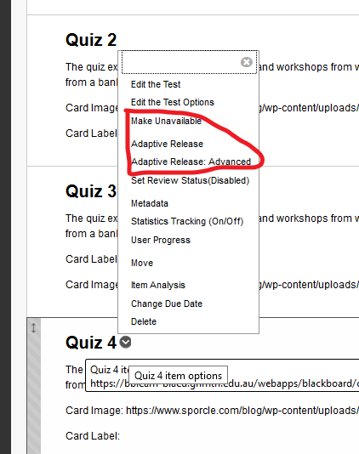

Figure 34 - Options for a Blackboard content item

## What you will see in edit mode

With *edit mode* on you will still be able to see cards that you have hidden. A card that has been hidden will show a message. As shown in Figure 35.

Cards with adaptive release applied will currently NOT show any message.

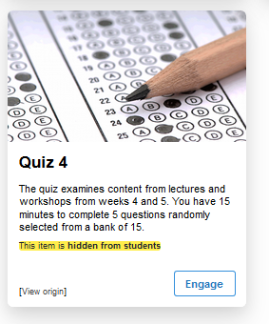

Figure 35 - Card for an unavailable item showing the "hidden" message

## What you and students will see when not in edit mode

With *edit mode* off you will see the cards closer to what students see.

Cards that are marked unavailable will not be shown.

Cards with adaptive release applied will not be shown if you meet the adaptive release rules. For example, if an item is limited only to people in a group. You will only see the matching card if you are in the group.

# Making a “Coming Soon” card

At the start of a teaching period you may have mapped out all the modules for a course. However, you haven’t yet completed all the content for all the modules. You want students to be able to see all the modules (represented by cards). Thereby gaining an overview of what the course will cover. However, you don’t want students to see the content for the incomplete modules (e.g. see Figure 36). This is where **Card Coming Soon** can help.

**Hiding a card** (see previous section) **versus A “coming soon” card**

Hiding a card means that the students can never see the card. Only someone with Edit Mode on (i.e. teaching staff) will be able to see a hidden card.

Adding “coming soon” to a card means the card is still visible to students. However, the card is modified so the student is unable to click on the card and see the associated content.

Hidden cards rely on Blackboard’s services and are secure and cannot be worked around. “Coming soon” cards rely on the student’s browser and can (with some technical knowledge) be worked around.

## How “coming soon” cards work

Figure 36 shows a Card Interface as of the 29th of November. Two of the cards have been turned into “coming soon” cards. The second card is “coming” on and after November 30 at 12:01am. The third card is coming between December 7 (12:01am) and January 10 (11:59pm).

**Default Times**

If only days are used when specifying when a “coming soon” is available default times are assumed (as shown in Figure 29). There are two possible default times:

1. For a one off or a start date the default time is 12:01am.
2. For a stop date the default time is 11:59pm.

Until the “coming soon” times specified the cards will display the yellow bar in the middle of the card with a message indicating when the cards will be available. Until those times students can see the cards and any detail on the card. However, they are unable to click on the cards and see the content.

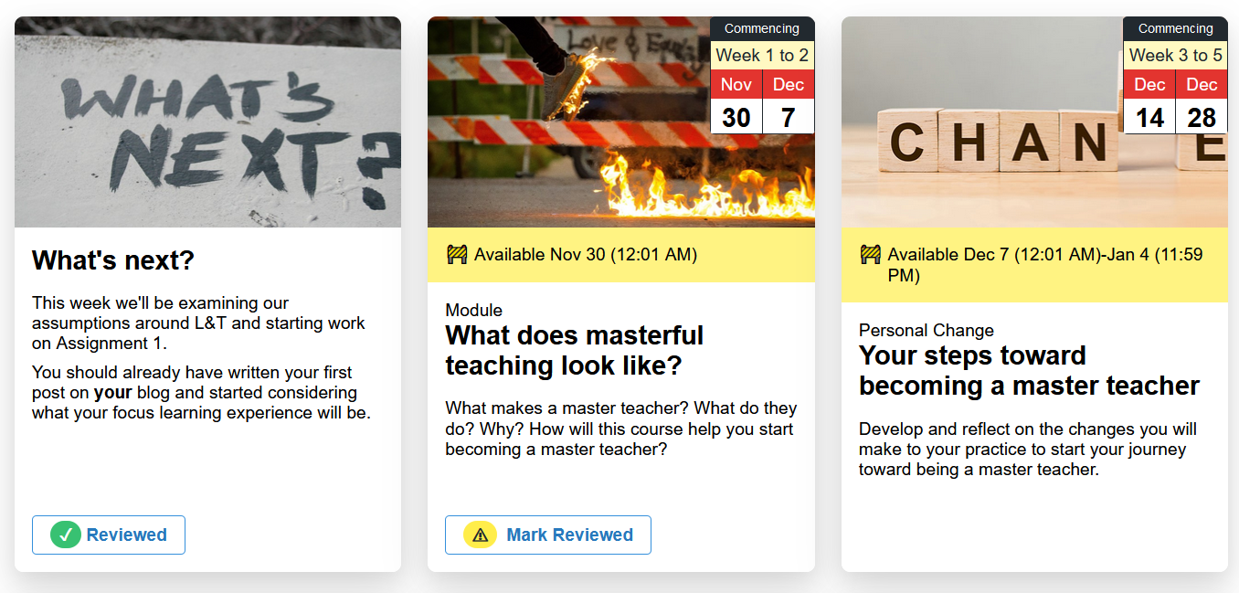

Figure 36 - Coming Soon cards - displayed on 29 November.

Figure 37 shows the same card interface but displayed on December 1. Since this is after November 30 the second card is no longer displaying the “coming soon” message. The second card is also displaying the **Engage** button. Indicating that students can now click on the card (or the Engage button) and access the associated content.

The third card retains its “coming soon” message and cannot be clicked on by students. This will only change between and including the dates of December 7 and January 10.

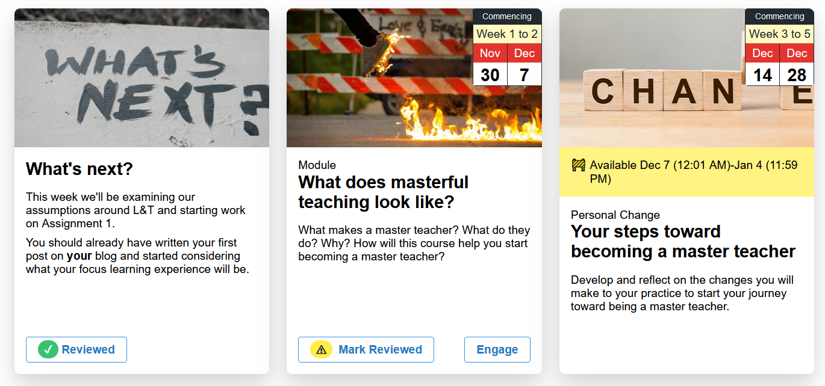

Figure 37 - Coming soon cards - displayed on 1 December

## How to make a “coming soon” card

A card becomes a “coming soon” card by the inclusion of the card variable **Card Coming Soon** in the card’s content item. For example, Figure 38 shows the content item for the third card in Figure 36 and Figure 37. It includes a **Card Coming Soon** card variable specifying the period when the card will be available.

The value for this variable uses the same format as for **Card Date**. The following table shows some examples of using a Griffith University date (e.g. Week 1), an explicit date (e.g. Nov 30), and date ranges (e.g. Dec 7-Dec 12).

**Time is optional and uses a 24-hour format**

You can specify just a date, or you can specify a date and a time. If you specify a time then use a [24-hour format](https://simple.wikipedia.org/wiki/24-hour_clock).

|  |  |
| --- | --- |
| **Example** | **Available** |
| Card Coming Soon: Week 1 | From Monday of Week 1 (as defined by the Griffith University academic calendar as applicable to the teaching period of the current course site) onwards |
| Card Coming Soon: Week 1 15:30 | Same as above, but starting at 3:30PM |
| Card Coming Soon: Nov 30 | From November 30 onwards |
| Card Coming Soon: Nov 30 6:00 | From 6:00am on November 30 |
| Card Coming Soon: Week 2-6 | Between (and including) the Monday of Week 2 (as per the Griffith calendar and course site) and the Sunday of Week 6 |
| Card Coming Soon: Week 2 9:00-6 17:00 | From 9:00am on Monday of Week 2 through to 5:00pm on the Sunday of Week 6 |
| Card Coming Soon: Dec 7-Dec 12 | Between Dec 7 and Dec 12 |
| Card Coming Soon: Dec 7-Dec 12 15:00 | From Dec 7 (12:01am) through to 3:00pm on Dec 12 |
| Card Coming Soon: Dec 7-Jan 10 | Between Dec 7 and Jan 10 |

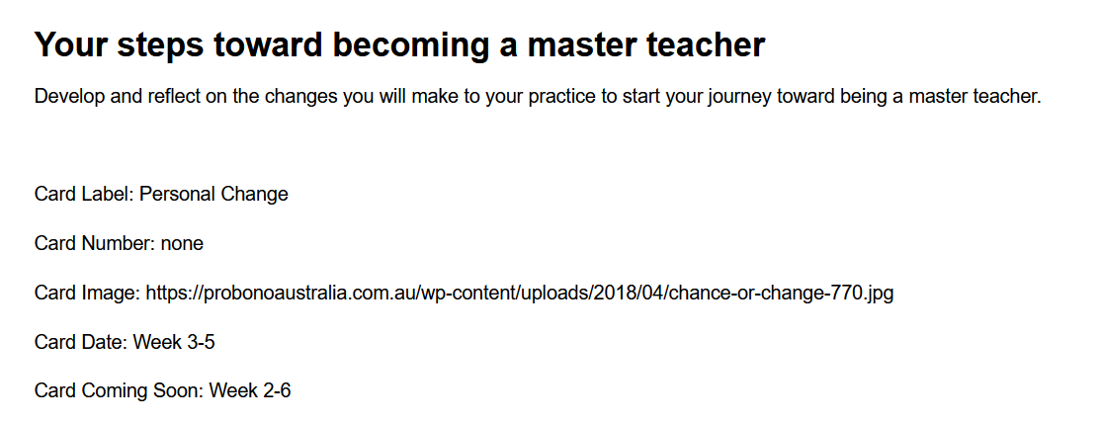

Figure 38 - Basic configuration for a "coming soon" card

### Changing the “Card Coming Soon Label”

As shown in Figure 36, the “coming soon” date will be preceded by **Available**. This is the default “Card Coming Soon Label”. You can use the “Card Coming Soon Label” card variable to change this label.

For example, Figure 39 shows a “coming soon” card using

Card Coming Soon Label: Only playing during

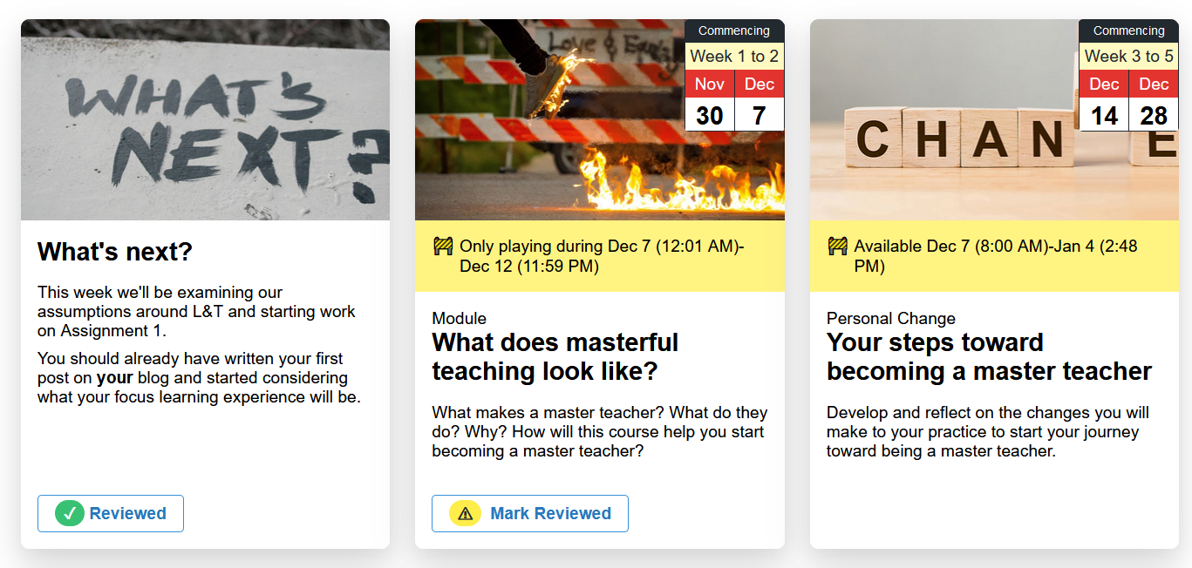

Figure 39 - Card Coming Soon label set to "Only playing during"

# Enabling “Review Status”

[“Review Status”](https://elearn.southampton.ac.uk/blackboard/reviewstatus-setup/) is a Blackboard feature that allows students to mark items as reviewed. It also enables teachers to view what items students have marked as reviewed.

“Review Status” is set per item in Blackboard – [see these instructions](https://elearn.southampton.ac.uk/blackboard/reviewstatus-setup/). With “Review Status” on there are two possible states for an item:

1. Mark Reviewed (Figure 40); and  
   Indicating that the student can mark this item as reviewed
2. Reviewed (Figure 41).  
   Indicating that the student has marked this item as reviewed.

The changes to the Card Interface shown in Figure 40 and Figure 41 are only visible when *Edit Mode* is off.

|  |  |
| --- | --- |
| A screenshot of a social media post  Description automatically generated  Figure 40 - Card to be Mark Reviewed | A screenshot of a cell phone  Description automatically generated  Figure 41 - Card that has been reviewed |

With *Edit Mode* on the Card will be displayed as per normal and the now visible content item will show Review has been enabled, as illustrated in Figure 42.

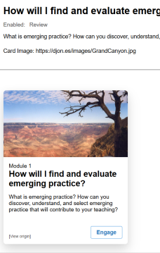

Figure 42 - Review Status on but Edit mode off